**Problem Statement ID = 1648**

**Problem Statement Title= Online Chatbot based ticketing system**

**Description:**

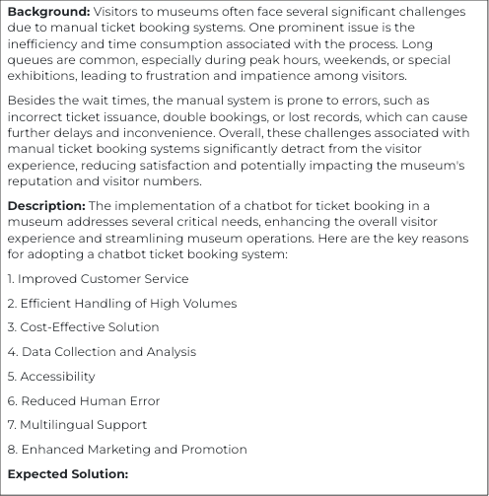

**OBJECTIVE:**

To design and implement a chatbot-based ticketing system that revolutionizes the museum experience by eliminating the inefficiencies of manual booking processes, providing enhanced accessibility, and enabling data-driven decision-making for museum management.

**METHODS:**

* A user-friendly graphical user interface (GUI) accessible 24/7 will be implemented to **facilitate a seamless customer experience**. The chatbot will be equipped to accept customer inquiries, address problems, and provide real-time status checks for bookings.
* To **handle high volumes efficiently,** the system will utilize reliable server connections with data retrieval and backup systems. Additionally, limiting the maximum number of bookings per time slot will optimize resource allocation.
* **Cost-effectiveness** will be prioritized by leveraging existing APIs, implementing automated testing procedures, and utilizing a free platform. This will minimize resource requirements for museum ownership.
* **Data collection and analysis** will include user demographics (age, gender), offered ticket types, government ID verification, and seasonal trends to understand visitor behavior and preferences.
* **Accessibility:**

. 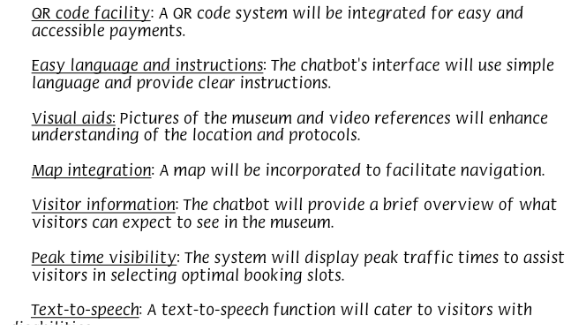

* **Reduced Human Error:**

Financial accuracy: The system will minimize financial errors and discrepancies.

Double booking prevention: A mechanism will be implemented to prevent double bookings.

Time slot management: The chatbot will ensure that time slots are not allocated beyond capacity.

* **Multilingual Support:**

Translation integration: A translation tool (e.g., Google Translate) will be integrated to support multiple languages.

* **Enhanced Marketing:**

Data-driven offers: The collected data will be used to create targeted offers and packages.

Seasonal promotions: Seasonal-based promotions will be offered to attract visitors during specific periods.

Group discounts: Discounts will be provided for group visits.

**CONCLUSION:**

By implementing this chatbot-based ticketing system, we anticipate improved customer service, efficient handling of high volume bookings, reduced operational costs, and valuable insights into visitor demographics and preferences. This will ultimately lead to a more streamlined and enjoyable visitor experience.